**Microwave (Individual)**

**Emilio Lopez**

**Due: 5/7/2014**

Table of Contents

**Introduction** ……..……………………………………………………………………………… 4

**Design**

Figures (Pictures) ………………………………………………………………………… 3

Peripherals ……………………………………………………………………………….. 5

General Software Implementation ……………………………………………………….. 5

Flow Chart ……………………………………………………………………………….. 6

**Conclusion** ……………………………………………………………………………………… 7

**Appendices**

User Manuel ……………………………………………………………………………... 8

*Code*

main.asm ....……………………………………………………………………… 9

CHECK_STATUS.asm ………………………………………………………... 13

IRQ_SER.asm ………………………………………………………………….. 16

MAIN_MENU.asm …………………………………………………………….. 19

SET_WATT.asm ………………………………………………………………. 20

SET_TIME.asm ………………………………………………………………... 23

SET_MOTOR_SPEED.asm …………………………………………………… 25

COOK_MENU.asm ………………………………………………………….… 30

SPIN_STEPPER_MOTOR.asm……………………….……………………….. 32

HEX_READ.asm ………………………………………………………………. 34

DISP_TIME.asm ……………………………………………………………….. 36

COOL_DOWN_DISPLAY.asm………………………………………………... 39

**Table Figures**

Hex Key Pad

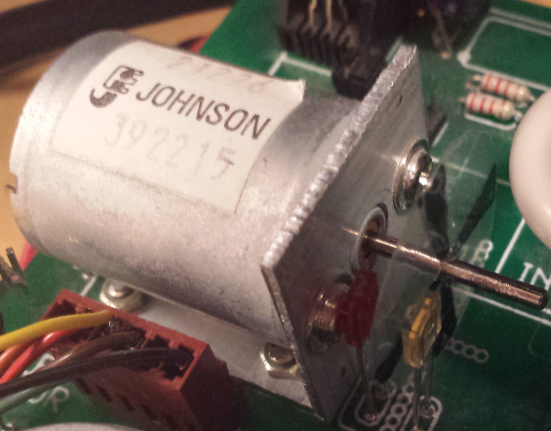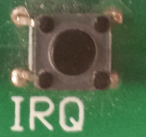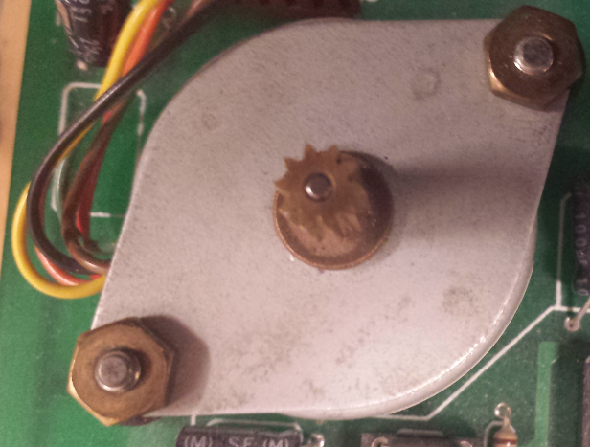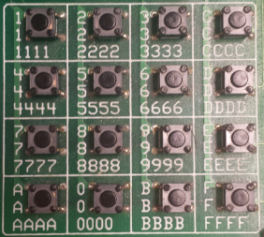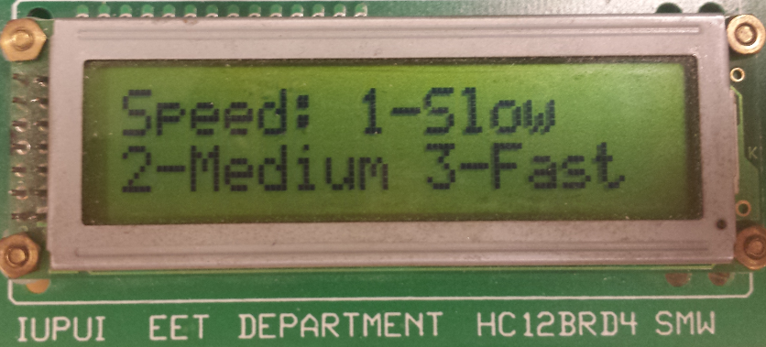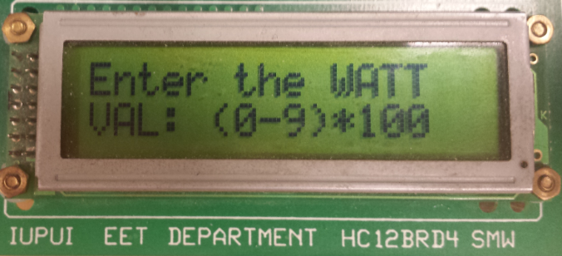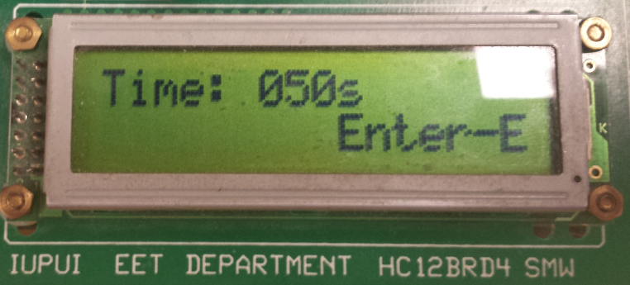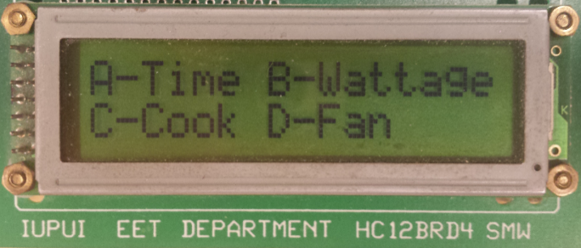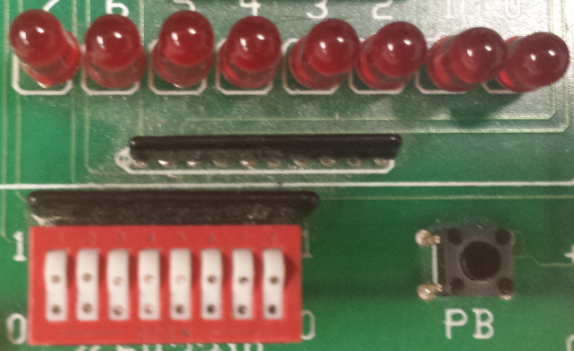

Potentiometer

Fan Speed Menu

Wattage Menu

Time Menu

Main Menu

LEDs and Switches

DC Motor (Fan)

IRQ   
(Emergency button)

Stepper Motor

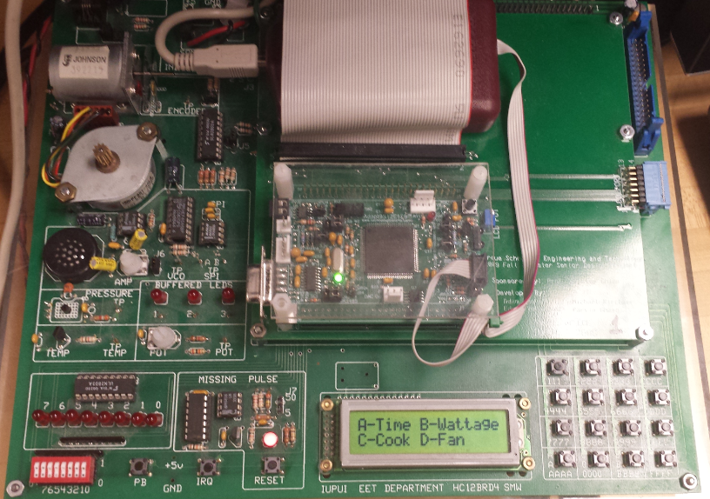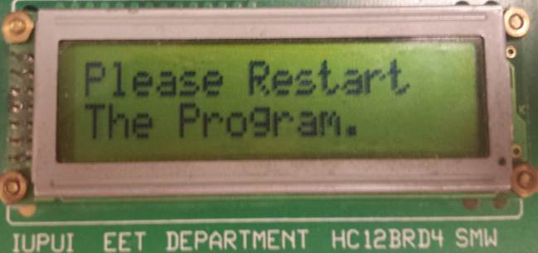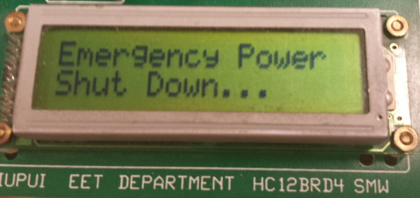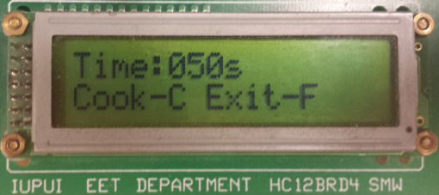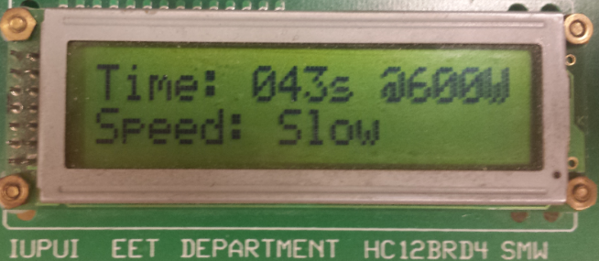

Entire Board

End of Program

Power Shut Down

(After IRQ Pressed)

Specs (Run Time)

Cook Menu

**Introduction**

The purpose of this project is to write an assembly program to simulate a microwave. The MC9S12E128 microcontroller was used to as the simulator. Throughout the course of the entire project, all concepts in both the laboratory and in lecture were to be utilized as tools and to be expanded upon to implement such a complex simulation. The I/O ports are utilized to give a visual simulation of how the microwave behaving at certain instances of time.

**Design**

Peripherals

A list of all the peripherals that are used in the project are as follows:

* *Stepper-Motor*: Used to rotate the microwave plate when it is running. The plate runs clockwise during cook time, and counter clockwise during cooling time.
* *DC-Motor:* Used as the microwave’s fan (Fast/Medium/Slow/Off speed options)
* *Keypad:* Used to navigate through the menus, set wattage, fan speed, and start the microwave.
* *Potentiometer:* Used to set the cook time of the microwave
* *LCD:* Used to display the different menus, during runtime shows spin time, wattage, and fan status, and lastly to display the remaining cook time.
* *Switches:* One switch is the status of the microwave door (open/closed), another switch is for the fan (0 off, 1 on)
* *LEDs:* LED 7 displays that the microwave is cooking, LED 0 shows that the microwave is cooling, all LEDs display rapidly when the emergency power down button has been pressed (IRQ)
* *IRQ:* Turns the microwave off immediately and terminates the assembly program.
* *RTI:* Used to control time and check various different statuses of multiple ports.

General Software Implementation

The software implementation of this microwave simulation implements several methods and functions that were constructed in previous labs. The microcontroller first starts off by displaying on the LCD screen the main menu with four different options to select from using the keypad. This main menu was implemented by using the given code files from previous labs (*.c files). In the main menu, the first loop continuously jumped to the HEX_READ routine which checked to see whether a button has been press. The options to go into the different menus are A, B, C, and D. When a button has been selected to go to a different menu a different subroutine that corresponds to that selection updates the LCD and different variables (speed, time, and wattage) can be selected. The speed of the fan from the speed menu has three different options; slow medium and fast speed. The speed and wattage is selected using the hex keypad. However, the cook time is selected by using the potentiometer. For the cook menu an RTI is used to check whether switch 7 is on (indicating that the microwave door is closed) and also the RTI checks to see if the button C has been selected from the hex key pad. If switch 7 is turned off (microwave is open) the microwave stops immediately and the cook time stays at the same time it was left at. If switch 7 is closed (microwave door is closed), then the microwave begins to cook at the time where it was last left at. During the time the microwave is in cook mode, four different subroutines are called to perform various tasks. These tasks include; spinning the stepper motor (using a stepper motor routine), spinning the fan at the speed in which the user selected (automatically fast if no speed has been selected), calling a subroutine to refresh the LCD, and lastly to utilize the RTI to count elapsed time in seconds and decrement the cook time that is being displayed to the LCD. During the time the microwave is in cook mode, if the IRQ button has been pushed, an interrupted is called and displays on the LCD “Emergency Power Shut Down…” while the LEDs rapidly flash. After about three seconds, the LCD updates and displays “Please Restart The Program.”. After this display, it terminates the program and the entire program must be restarted to make the microwave function once again. A flow chart below give a visual description of the entire program

Simulation Flow Chart

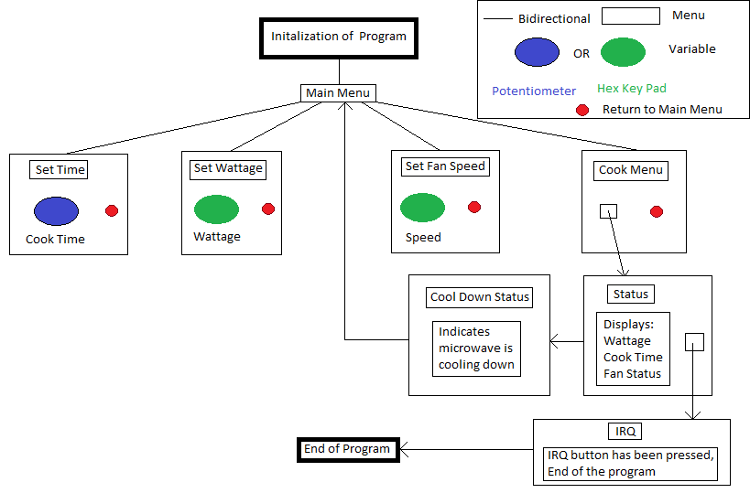

There were a few changes that I did make to the entire design of the microwave project. To begin with, I have meet all of the requirements however I was unable to implement the time of day into the time menu and was the only part of the project that was not working. I added the IRQ functionality as it was not part of the individual project requirements and made the LEDs flash rapidly when displaying the power shutdown display. Additionally I added the functionality of the opening and closing the door to the microwave which keeps the cook time when opened, and resumes at that time when closed (all done with switch 7 of port T).

Conclusion

In conclusion I believe that this microwave project was overall a successful accomplishment. Though implementation of all parts and integrating different functionalities together was difficult at time. It is imperative to ensure that all of the code that is written has meaningful comment block to help the creator understand what is exactly going on in a subroutine when referred back to at a later time. Utilizing the debugger is an excellent to in identifying what bug/issue may be going on with the program during run time. Additionally it is important to run the program as frequently as possible to ensure when writing a function/subroutine in the program, that it works properly and the program still runs. Lastly I strongly believe that when working on such massive projects, it is crucial to frequently save the program to either an external drive or on the cloud. The reason being is that, if for whatever reason the program crashes or has a very complex to near unidentifiable bug, that the creator can go back to a previous version of the project that is functioning.

**Appendices**

User Manuel

To begin with, please refer to the simulation flow chart above to get a good understanding of how the microwave has been implemented. To turn the microwave on, in the debugger window select the run button to initialize the program. The main menu will appear on the LCD with a list of different menus that can be navigated to. To select these different menus enter either A, B, C, or D from the hex keypad. When setting the wattage and fan speed, please use the hex keypad to enter the value. For selecting a time in the time menu, use the potentiometer to increase or decrease the cook time. All submenus return to the main menu either when a value has been entered or the respective button to go back to the main menu has been selected. To open or close the door turn switch 7 on port T (the furthest switch to the left up (door closed) or down (door open)). Always ensure that fourth switch from the left is always switched upwards to enable the functionality of the DC Motor (the microwave fan). In the cook menu, ensure that switch 7 is switched upwards, and press C to cook. The specifications of the parameters will display on the screen. To turn the fan on during runtime flip the right most switch (switch 0) upwards to turn the fan on. Once the cook time runs to zero, the LCD returns to the main menu. To immediately shut down the microwave for safety issues, press the IRQ button to terminate the program and turn the microwave off. Once this has been pressed the microwave program needs to be restarted.

Code

**Main.asm**

;**************************************************************

;* This stationery serves as the framework for a *

;* user application. For a more comprehensive program that *

;* demonstrates the more advanced functionality of this *

;* processor, please see the demonstration applications *

;* located in the examples subdirectory of the *

;* Freescale CodeWarrior for the HC12 Program directory *

;**************************************************************

; Include derivative-specific definitions

INCLUDE 'derivative.inc'

; export symbols

XDEF Entry, _Startup, main, port_S, ROW_VAL, COORD_TBL, VALUE_TBL, HEX_VALUE , port_T,port_T_DDR, ON_OFF, port_U,port_U_DDR, port_U_PSR,PERUu

XDEF COOL_Y_N,disp,WATTAGE, START_COOKING_Y_N, RUN_TIME, SPIN_SPEED_OPTION, SLOW_SPEED_COUNT, MED_SPEED_COUNT, TIME_COUNTER

; we use export 'Entry' as symbol. This allows us to

; reference 'Entry' either in the linker .prm file

; or from C/C++ later on

XREF __SEG_END_SSTACK, CHECK_STATUS, HEX_READ, SPIN_STEPPER_MOTOR,SET_WATT,SET_TIME,MAIN_MENU,DISP_TIME, read_pot,pot_value ; symbol defined by the linker for the end of the stack

XREF COOK_MENU, COOL_DOWN_DISPLAY, SET_MOTOR_SPEED

; variable/data section

MY_EXTENDED_RAM: SECTION

; Insert here your data definition.

WATTAGE: ds.b 1

HEX_VALUE: ds.b 1

TIME_SECOND: ds.b 1;runtime of the microwave

ON_OFF: ds.b 1;power status of the microwave

COOL_Y_N: ds.b 1;checks to see if the microwave timer has ran out

LCD_SECTION: ds.b 1

START_COOKING_Y_N: ds.b 1;checks to see if c has been press from key pad in COOK_MENU

RUN_TIME: ds.w 1 ;runtime extracted from the pot

SPIN_SPEED_OPTION: ds.b 1;spin speed of the dc motor

SLOW_SPEED_COUNT: ds.b 1

MED_SPEED_COUNT: ds.b 1

TIME_COUNTER: ds.b 1

disp: ds.b 33

My_Constants: SECTION

;====================================================================================================================

port_T: equ $240

port_T_DDR: equ $242

;====================================================================================================================

;LED RELATED

port_S: equ $248

port_S_DDR: equ $24A

;====================================================================================================================

;HEX RELATED

port_U: equ $268;Port U bits

port_U_DDR: equ $26A;Direction Register

port_U_PSR: equ $26D;Polarity Select Register

PERUu: equ $26C;Pull up Registers

counter_1: equ 65000

counter_2: equ 1000

ROW_VAL: dc.b $70,$b0,$d0,$e0,$ff; is at begining to compensate for iny at beginning of ROW_LOOP

COORD_TBL: dc.b $77,$7b,$7d,$7e,$b7,$bb,$bd,$be,$d7,$db,$dd,$de,$e7,$eb,$ed,$ee,$ff;the ternimator

VALUE_TBL: dc.b $1,$2,$3,$c,$4,$5,$6,$d,$7,$8,$9,$e,$a,$0,$b,$f

;==========================================================

;RTI RELATED

MYRTIFLG: equ $0037 ; RTI flag register address CRGFLG

MYRTIENA: equ $0038 ; RTI init register address CRGINT

MYRTICTL: equ $003B ; RTI control register address RTICTL

; code section

MyCode: SECTION

main:

_Startup:

Entry:

lds #__SEG_END_SSTACK ;initalize stack

movb #%1000, port_T_DDR;for the dc motor to spin

movb #0,COOL_Y_N;0 means it is not in a cool down cycle

movb #0,ON_OFF;initalizes the on off status

movb #0,TIME_SECOND;value extracted from the potentiometer

;movb #0,TIME_MINUTE;value extracted from the potentiometer

movb #$ff,port_S_DDR

movb #0,HEX_VALUE

movb #0,TIME_COUNTER;default timer counter for rti is 0

movb #$17, MYRTICTL ;1MS DELAY

movb #$80, MYRTIENA ;Enable RTI

ldaa #0

staa START_COOKING_Y_N;initailization

staa RUN_TIME ;initailization

;need to initialize vector table in linker parameter file

cli ;enable interrupt

jsr MAIN_MENU;init main menu on LCD

;====================================================================================================================

AGAIN:

ldaa ON_OFF

cmpa #1;if the micro wave is on

beq INIT;start the microwave if it is on

jsr HEX_READ

cmpa #$a;chose the menu to set the time

beq TIME_SET

cmpa #$b;chose the menu to set the wattage

beq WATT_SET

cmpa #$c;chose the menu to set the wattage

beq COOK_SET

cmpa #$d;chose the menu to set the wattage

beq MOTOR_SET

bra AGAIN

;====================================================================================================================

TIME_SET:

jsr SET_TIME

bra AGAIN

;====================================================================================================================

WATT_SET: jsr SET_WATT;go set the wattage routine

bra AGAIN

;====================================================================================================================

COOK_SET:

jsr COOK_MENU

bra AGAIN

;====================================================================================================================

MOTOR_SET:

jsr SET_MOTOR_SPEED

bra AGAIN

;====================================================================================================================

INIT:

ldaa #3

jsr DISP_TIME;DISPLAY STATUS

staa SLOW_SPEED_COUNT

ldaa #1

staa MED_SPEED_COUNT

movb #%10000000,port_S;bit 7 is turned on to indicate on time

jsr SPIN_STEPPER_MOTOR;spin the motor

;jsr DISP_LCD;displaying runtime

ldaa ON_OFF

beq COOL_DOWN;means it is off;

jsr DISP_TIME;displays time left on LCD

bra AGAIN

COOL_DOWN: movb #1,COOL_Y_N

jsr COOL_DOWN_DISPLAY;display to the lcd that the microwave is cooling down

movb #%00000001,port_S;cool down phase

jsr SPIN_STEPPER_MOTOR;now in the cool down phase

movb #0,port_S

jsr MAIN_MENU;reset main menu to lcd

bra AGAIN

end

**CHECK_STATUS.asm**

xdef CHECK_STATUS

xref SECOND,port_S,ON_OFF, port_T, port_T_DDR,START_COOKING_Y_N,SPIN_SPEED_OPTION, SLOW_SPEED_COUNT, MED_SPEED_COUNT, DISP_TIME, TIME_COUNTER

xref RUN_TIME

My_Constants: SECTION

RTIE: equ $80

CHECK_STATUS:

brset port_T,%10000000,MICRO_ON;check if bit 0 is on, if so the fan is on

;===================================================================================================================

MICRO_OFF: movb #0,ON_OFF;the microwave is off

bclr port_T,%1000;turn the DC MOTOR OFF

ldaa #RTIE ;re-enable interrupt

staa $37

rti

MICRO_ON:

ldaa START_COOKING_Y_N;to check if C has been pressed in the cook menu

cmpa #1

bne EXIT

;TIME CHECKER

ldx TIME_COUNTER

inx ;increase ms counter in memory

stx TIME_COUNTER

cpx #860 ;equal to 1 second?

bne SWITCH_ON_OFF_CHECK;means it has not been 1s yet

ldx #0 ;reset to 0 if = 1 sec

stx TIME_COUNTER

jsr DISP_TIME

ldd RUN_TIME

cmpb #0

beq EXIT

decb

std RUN_TIME

SWITCH_ON_OFF_CHECK:

movb #1,ON_OFF;the microwave is on

ldaa #RTIE ;re-enable interrupt

staa $37

brset port_T,%00000001,SPIN_FAN;check if bit 0 is on, if so the fan is on

bclr port_T,%1000;turn the DC MOTOR OFF

rti

SPIN_FAN:

ldaa SPIN_SPEED_OPTION

cmpa #1;slow spin speed

beq SLOW_FAN_SPEED

cmpa #2;medium spin speed

beq MED_FAN_SPEED

bset port_T,%1000;Otherwise it is a fast spin speed

rti

;========================================================================================================

SLOW_FAN_SPEED:

ldaa SLOW_SPEED_COUNT

beq SLOW_FAN_SPEED_INIT

deca

staa SLOW_SPEED_COUNT

bclr port_T,%1000;turn the DC MOTOR OFF

rti

SLOW_FAN_SPEED_INIT:

ldaa #3

staa SLOW_SPEED_COUNT

bset port_T,%1000;turn the DC MOTOR OFF

rti

;========================================================================================================

MED_FAN_SPEED:

ldaa MED_SPEED_COUNT

beq MED_FAN_SPEED_INIT

deca

staa MED_SPEED_COUNT

bclr port_T,%1000;turn the DC MOTOR OFF

rti

MED_FAN_SPEED_INIT:

ldaa #2

staa MED_SPEED_COUNT

bset port_T,%1000;turn the DC MOTOR OFF

rti

EXIT:

movb #0,ON_OFF;the microwave is off

movb #0,START_COOKING_Y_N;resets the c button that has been clicked

bclr port_T,%1000;turn the DC MOTOR OFF

ldaa #RTIE ;re-enable interrupt

staa $37

rti

**IRQ_SER.asm**

XDEF IRQ_SER

XREF init_LCD,read_pot,pot_value,display_string, HEX_VALUE, port_S, HEX_READ, disp, port_T

IRQ_SER:

movb #'E',disp

movb #'m',disp+1

movb #'e',disp+2

movb #'r',disp+3

movb #'g',disp+4

movb #'e',disp+5

movb #'n',disp+6

movb #'c',disp+7

movb #'y',disp+8

movb #' ',disp+9

movb #'P',disp+10

movb #'o',disp+11

movb #'w',disp+12

movb #'e',disp+13

movb #'r',disp+14

movb #' ',disp+15

movb #'S',disp+16

movb #'h',disp+17

movb #'u',disp+18

movb #'t',disp+19

movb #' ',disp+20

movb #'D',disp+21

movb #'o',disp+22

movb #'w',disp+23

movb #'n',disp+24

movb #'.',disp+25

movb #'.',disp+26

movb #'.',disp+27

movb #' ',disp+28

movb #' ',disp+29

movb #' ',disp+30

movb #' ',disp+31

movb #0,disp+32 ;string terminator, acts like '\0'

jsr init_LCD

ldd #disp

jsr display_string

bclr port_T,%1000;turn the DC MOTOR OFF

ldx #8;loop again

FLASH:

pshx;temp save x

ldy #3

KEEP_DISPLAYING_1:;DELAY loop to keep displaying the value of wattage

movb #$0,port_S

ldd #disp

jsr display_string

movb #0,port_S

dey

bne KEEP_DISPLAYING_1

ldy #3

KEEP_DISPLAYING_2:;DELAY loop to keep displaying the value of wattage

movb #$ff,port_S

ldd #disp

jsr display_string

movb #0,port_S

dey

bne KEEP_DISPLAYING_2

pulx

dex

bne FLASH

STOP_COOLING:

bclr port_T,%1000;turn the DC MOTOR OFF

movb #'P',disp

movb #'l',disp+1

movb #'e',disp+2

movb #'a',disp+3

movb #'s',disp+4

movb #'e',disp+5

movb #' ',disp+6

movb #'R',disp+7

movb #'e',disp+8

movb #'s',disp+9

movb #'t',disp+10

movb #'a',disp+11

movb #'r',disp+12

movb #'t',disp+13

movb #' ',disp+14

movb #' ',disp+15

movb #'T',disp+16

movb #'h',disp+17

movb #'e',disp+18

movb #' ',disp+19

movb #'P',disp+20

movb #'r',disp+21

movb #'o',disp+22

movb #'g',disp+23

movb #'r',disp+24

movb #'a',disp+25

movb #'m',disp+26

jsr init_LCD

ldd #disp

jsr display_string

end

**MAIN_MENU.asm**

XDEF MAIN_MENU

XREF init_LCD,read_pot,pot_value,display_string, HEX_VALUE, port_S, HEX_READ, disp

MAIN_MENU:

movb #'A',disp

movb #'-',disp+1

movb #'T',disp+2

movb #'i',disp+3

movb #'m',disp+4

movb #'e',disp+5

movb #' ',disp+6

movb #'B',disp+7

movb #'-',disp+8

movb #'W',disp+9

movb #'a',disp+10

movb #'t',disp+11

movb #'t',disp+12

movb #'a',disp+13

movb #'g',disp+14

movb #'e',disp+15

movb #'C',disp+16

movb #'-',disp+17

movb #'C',disp+18

movb #'o',disp+19

movb #'o',disp+20

movb #'k',disp+21

movb #' ',disp+22

movb #'D',disp+23

movb #'-',disp+24

movb #'F',disp+25

movb #'a',disp+26

movb #'n',disp+27

movb #' ',disp+28

movb #' ',disp+29

movb #' ',disp+30

movb #' ',disp+31

movb #0,disp+32 ;string terminator, acts like '\0'

jsr init_LCD

ldd #disp

jsr display_string

rts

**SET_WATT.asm**

**XDEF SET_WATT**

**XREF init_LCD,read_pot,pot_value,display_string, HEX_VALUE, port_S, HEX_READ, disp, WATTAGE, MAIN_MENU**

**SET_WATT:**

**movb #'E',disp**

**movb #'n',disp+1**

**movb #'t',disp+2**

**movb #'e',disp+3**

**movb #'r',disp+4**

**movb #' ',disp+5**

**movb #'t',disp+6**

**movb #'h',disp+7**

**movb #'e',disp+8**

**movb #' ',disp+9**

**movb #'W',disp+10**

**movb #'A',disp+11**

**movb #'T',disp+12**

**movb #'T',disp+13**

**movb #' ',disp+14**

**movb #' ',disp+15**

**movb #'V',disp+16**

**movb #'A',disp+17**

**movb #'L',disp+18**

**movb #':',disp+19**

**movb #' ',disp+20**

**movb #'(',disp+21**

**movb #'0',disp+22**

**movb #'-',disp+23**

**movb #'9',disp+24**

**movb #')',disp+25**

**movb #'*',disp+26**

**movb #'1',disp+27**

**movb #'0',disp+28**

**movb #'0',disp+29**

**movb #' ',disp+30**

**movb #' ',disp+31**

**movb #0,disp+32 ;string terminator, acts like '\0'**

**;*********************string initialization\*\*\*\*\*\*\*\*\*\*\*\*\*\*\*\*\*\*\*\*\***

**;\*\*\*\*\*\*\*\*\*\*\*\*\*\*\*\*\*\*\*\*\*\*\*\*\*\*\*\*\*\*\*\*\*\*\*\*\*\*\*\*\*\*\*\*\*\*\*\*\*\*\*\*\*\*\*\*\*\*\*\*\*\***

**jsr init_LCD**

**movb #$ff,HEX_VALUE;init hex value to ensure something is pressed**

**ldy #disp;starting address**

**Loop: jsr HEX_READ;go to the hex read subroutine**

**ldd #disp**

**jsr display_string**

**ldaa HEX_VALUE**

**staa port_S**

**cmpa #$ff;checks to see if the hex value is the same as the initailzation**

**;this means that the hex keypad has not been changed**

**beq Loop**

**;\*\*\*\*\*\*\*\*\*\*\*\*\*\*\*\*\*\*\*\*\*\*\*\*\*\*\*\*\*\*\*\*\*\*\*\*\*\*\*\*\*\*\*\*\*\*\*\*\*\*\*\*\*\*\*\*\*\*\*\*\*\***

**movb #'Y',disp**

**movb #'o',disp+1**

**movb #'u' ,disp+2**

**movb #' ',disp+3**

**movb #'e',disp+4**

**movb #'n',disp+5**

**movb #'t',disp+6**

**movb #'e',disp+7**

**movb #'r',disp+8**

**movb #'e',disp+9**

**movb #'d',disp+10**

**movb #':',disp+11**

**movb #' ',disp+12**

**movb #'0',disp+13**

**movb #'0',disp+14**

**movb #'W',disp+15**

**movb #' ',disp+16**

**movb #' ',disp+17**

**movb #' ',disp+18**

**movb #' ',disp+19**

**movb #' ',disp+20**

**movb #' ',disp+21**

**movb #' ',disp+22**

**movb #' ',disp+23**

**movb #' ',disp+24**

**movb #' ',disp+25**

**movb #' ',disp+26**

**movb #' ',disp+27**

**movb #' ',disp+28**

**movb #' ',disp+29**

**movb #' ',disp+30**

**movb #' ',disp+31**

**movb #0,disp+32 ;string terminator, acts like '\0'**

**staa WATTAGE;stores the watage value into the constant**

**adda #48;convert to ascii**

**staa disp+12**

**ldy #30**

**KEEP_DISPLAYING:;DELAY loop to keep displaying the value of wattage**

**ldd #disp**

**jsr display_string**

**dey**

**bne KEEP_DISPLAYING**

**jsr MAIN_MENU;resets the LCD to main menu**

**rts**

**SET_TIME.asm**

XDEF SET_TIME

XREF init_LCD,read_pot,pot_value,display_string, HEX_VALUE, HEX_READ, disp, MAIN_MENU, RUN_TIME

My_variable: section

hundreds_place: ds.b 1

tens_place: ds.b 1

ones_place: ds.b 1

SET_TIME:

movb #'T',disp

movb #'i',disp+1

movb #'m',disp+2

movb #'e',disp+3

movb #':',disp+4

movb #' ',disp+5

movb #'0',disp+6

movb #'0',disp+7

movb #'0',disp+8

movb #'s',disp+9

movb #' ',disp+10

movb #' ',disp+11

movb #' ',disp+12

movb #' ',disp+13

movb #' ',disp+14

movb #' ',disp+15

movb #' ',disp+16

movb #' ',disp+17

movb #' ',disp+18

movb #' ',disp+19

movb #' ',disp+20

movb #' ',disp+21

movb #' ',disp+22

movb #' ',disp+23

movb #' ',disp+24

movb #'E',disp+25

movb #'n',disp+26

movb #'t',disp+27

movb #'e',disp+28

movb #'r',disp+29

movb #'-',disp+30

movb #'E',disp+31

movb #0,disp+32 ;string terminator, acts like '\0'

;*********************string initialization*********************

;**************************************************************

jsr init_LCD

movb #$ff,HEX_VALUE;init hex value to ensure something is pressed

ldy #disp;starting address

ldd #disp

jsr display_string

KEEP_READING:

jsr read_pot

ldd pot_value

ldx #100;hundres place

idiv

tfr x,a

adda #48

staa disp+6

ldaa #0;reset a to its original value which will always be 0

ldx #10 ;tens place

idiv

tfr x,a

adda #48

staa disp+7

ldaa #0;reset a to its original value which will always be 0

addb #48 ;ones place

stab disp+8

ldd #disp

jsr display_string

jsr HEX_READ

ldaa HEX_VALUE

cmpa #$0e;checks to see if the user wants to exit the main menu

bne KEEP_READING

ldd pot_value

std RUN_TIME

jsr MAIN_MENU;resets the lcd to main menu

rts

**SET_MOTOR_SPEED.asm**

XDEF SET_MOTOR_SPEED

XREF init_LCD,read_pot,pot_value,display_string, HEX_VALUE, port_S, HEX_READ, disp, WATTAGE, MAIN_MENU, SPIN_SPEED_OPTION

SET_MOTOR_SPEED:

movb #'S',disp

movb #'p',disp+1

movb #'e',disp+2

movb #'e',disp+3

movb #'d',disp+4

movb #':',disp+5

movb #' ',disp+6

movb #'1',disp+7

movb #'-',disp+8

movb #'S',disp+9

movb #'l',disp+10

movb #'o',disp+11

movb #'w',disp+12

movb #' ',disp+13

movb #' ',disp+14

movb #' ',disp+15

movb #'2',disp+16

movb #'-',disp+17

movb #'M',disp+18

movb #'e',disp+19

movb #'d',disp+20

movb #'i',disp+21

movb #'u',disp+22

movb #'m',disp+23

movb #' ',disp+24

movb #'3',disp+25

movb #'-',disp+26

movb #'F',disp+27

movb #'a',disp+28

movb #'s',disp+29

movb #'t',disp+30

movb #' ',disp+31

movb #0,disp+32 ;string terminator, acts like '\0'

;*********************string initialization*********************

;read hex key pad

;================================================================================================================

jsr init_LCD

movb #$ff,HEX_VALUE;init hex value to ensure something is pressed

ldy #disp;starting address

ldy #1

Loop: jsr HEX_READ;go to the hex read subroutine

ldd #disp

jsr display_string

ldaa HEX_VALUE

cmpa #$01;

beq SLOW_SPEED

cmpa #$02

beq MED_JMP;cannot jump to the MED_SPEED bc out of range

cmpa #$03

beq FAST_JMP;cannot jump to the FAST_SPEED bc out of range

bra Loop;nothing has been selected

;================================================================================================================

MED_JMP:

jmp MED_SPEED

FAST_JMP:

jmp FAST_SPEED

;Slow speed

;================================================================================================================

SLOW_SPEED:

movb #'S',disp

movb #'L',disp+1

movb #'O' ,disp+2

movb #'W',disp+3

movb #' ',disp+4

movb #'s',disp+5

movb #'p',disp+6

movb #'e',disp+7

movb #'e',disp+8

movb #'d',disp+9

movb #' ',disp+10

movb #'h',disp+11

movb #'a',disp+12

movb #'s',disp+13

movb #' ',disp+14

movb #' ',disp+15

movb #'b',disp+16

movb #'e',disp+17

movb #'e',disp+18

movb #'n',disp+19

movb #' ',disp+20

movb #'s',disp+21

movb #'e',disp+22

movb #'l',disp+23

movb #'e',disp+24

movb #'c',disp+25

movb #'t',disp+26

movb #'e',disp+27

movb #'d',disp+28

movb #'.',disp+29

movb #' ',disp+30

movb #' ',disp+31

movb #0,disp+32 ;string terminator, acts like '\0'

ldaa #1; CHANGE!!!!!!!!!!!!!!!

staa SPIN_SPEED_OPTION

adda #48;convert to ascii

;staa disp+12

ldy #45

KEEP_DISPLAYING_SLOW:;DELAY loop to keep displaying the value of wattage

ldd #disp

jsr display_string

dey

bne KEEP_DISPLAYING_SLOW

jsr MAIN_MENU;resets the LCD to main menu

rts

;================================================================================================================

;Medium Speed

;================================================================================================================

MED_SPEED:

movb #'M',disp

movb #'E',disp+1

movb #'D' ,disp+2

movb #'.',disp+3

movb #' ',disp+4

movb #'s',disp+5

movb #'p',disp+6

movb #'e',disp+7

movb #'e',disp+8

movb #'d',disp+9

movb #' ',disp+10

movb #'h',disp+11

movb #'a',disp+12

movb #'s',disp+13

movb #' ',disp+14

movb #' ',disp+15

movb #'b',disp+16

movb #'e',disp+17

movb #'e',disp+18

movb #'n',disp+19

movb #' ',disp+20

movb #'s',disp+21

movb #'e',disp+22

movb #'l',disp+23

movb #'e',disp+24

movb #'c',disp+25

movb #'t',disp+26

movb #'e',disp+27

movb #'d',disp+28

movb #'.',disp+29

movb #' ',disp+30

movb #' ',disp+31

movb #0,disp+32 ;string terminator, acts like '\0'

ldaa #2; CHANGE!!!!!!!!!!!!!!!

staa SPIN_SPEED_OPTION

adda #48;convert to ascii

;staa disp+12

ldy #45

KEEP_DISPLAYING_MED:;DELAY loop to keep displaying the value of wattage

ldd #disp

jsr display_string

dey

bne KEEP_DISPLAYING_MED

jsr MAIN_MENU;resets the LCD to main menu

rts

;================================================================================================================

;Fast Speed

;================================================================================================================

FAST_SPEED:

movb #'F',disp

movb #'A',disp+1

movb #'S',disp+2

movb #'T',disp+3

movb #' ',disp+4

movb #'s',disp+5

movb #'p',disp+6

movb #'e',disp+7

movb #'e',disp+8

movb #'d',disp+9

movb #' ',disp+10

movb #'h',disp+11

movb #'a',disp+12

movb #'s',disp+13

movb #' ',disp+14

movb #' ',disp+15

movb #'b',disp+16

movb #'e',disp+17

movb #'e',disp+18

movb #'n',disp+19

movb #' ',disp+20

movb #'s',disp+21

movb #'e',disp+22

movb #'l',disp+23

movb #'e',disp+24

movb #'c',disp+25

movb #'t',disp+26

movb #'e',disp+27

movb #'d',disp+28

movb #'.',disp+29

movb #' ',disp+30

movb #' ',disp+31

movb #0,disp+32 ;string terminator, acts like '\0'

ldaa #3; CHANGE!!!!!!!!!!!!!!!

staa SPIN_SPEED_OPTION

adda #48;convert to ascii

; staa disp+12

ldy #45

KEEP_DISPLAYING_FAST:;DELAY loop to keep displaying the value of wattage

ldd #disp

jsr display_string

dey

bne KEEP_DISPLAYING_FAST

jsr MAIN_MENU;resets the LCD to main menu

rts

;================================================================================================================

**COOK_MENU.asm**

XDEF COOK_MENU

XREF init_LCD,read_pot,pot_value,display_string, HEX_VALUE, port_S, HEX_READ, disp, WATTAGE, MAIN_MENU, RUN_TIME, START_COOKING_Y_N

COOK_MENU:

;**************************************************************

movb #'T',disp

movb #'i',disp+1

movb #'m' ,disp+2

movb #'e',disp+3

movb #':',disp+4

movb #'0',disp+5

movb #'0',disp+6

movb #'0',disp+7

movb #'s',disp+8

movb #' ',disp+9

movb #' ',disp+10

movb #' ',disp+11

movb #' ',disp+12

movb #' ',disp+13

movb #' ',disp+14

movb #' ',disp+15

movb #'C',disp+16

movb #'o',disp+17

movb #'o',disp+18

movb #'k',disp+19

movb #'-',disp+20

movb #'C',disp+21

movb #' ',disp+22

movb #'E',disp+23

movb #'x',disp+24

movb #'i',disp+25

movb #'t',disp+26

movb #'-',disp+27

movb #'F',disp+28

movb #' ',disp+29

movb #' ',disp+30

movb #' ',disp+31

movb #0,disp+32 ;string terminator, acts like '\0'

;**************************************************************

jsr init_LCD

movb #$ff,HEX_VALUE;init hex value to ensure something is pressed

KEEP_DISPLAYING:;DELAY loop to keep displaying the value of wattage

;placing RUN_TIME value to array

;----------------------------------------------------------------------------------------

ldd RUN_TIME

ldx #100;hundres place

idiv

tfr x,a

adda #48

staa disp+5

ldaa #0;reset a to its original value which will always be 0

ldx #10 ;tens place

idiv

tfr x,a

adda #48

staa disp+6

ldaa #0;reset a to its original value which will always be 0

addb #48 ;ones place

stab disp+7

;display array to LCD

;-----------------------------------------------------------------------------------------

ldd #disp

jsr display_string

;-----------------------------------------------------------------------------------------

;read from the hex keypad

jsr HEX_READ

ldaa HEX_VALUE

cmpa #$0f

beq EXIT

cmpa #$0c

beq COOK

;-----------------------------------------------------------------------------------------

bra KEEP_DISPLAYING

EXIT: jsr MAIN_MENU;resets the LCD to main menu

rts

COOK:

ldaa #1

staa START_COOKING_Y_N

rts

**SPIN_STEPPER_MOTOR.asm**

**XDEF SPIN_STEPPER_MOTOR**

**XREF COOL_Y_N, ON_OFF**

**My_Const: SECTION**

**array: dc.b $ff,$0a,$12,$14,$0c,$ff ;sequence will be sent to the motor**

**port_P_DDR: equ $25a**

**port_P: equ $258**

**port_T: equ $240**

**; code section**

**MyCode: SECTION**

**SPIN_STEPPER_MOTOR:**

**ldaa port_P_DDR ;loads port p ddr into acc a**

**oraa #%00011110 ;sets the bits 1-4 in port p ddr**

**staa port_P_DDR ;places new value into port p ddr**

**RETRY:**

**ldy #65535**

**SAFE_DELAY:;safety delay for no sudden changes in rotating**

**dey**

**cpy #0**

**bne SAFE_DELAY**

**ldaa COOL_Y_N**

**beq CLOCK_W;not in a cool down phase**

**ldaa #7;this is for the cool down phase, it shall cool down for 10 cycles**

**psha**

**bra COUNTER_CW;it is a cool down phase**

**;====================================================================================================================**

**CLOCK_W:**

**ldx #array ;loads first element of array into reg. x**

**AGAIN_CW: ldab #1 ;acc. b will act as a counter**

**LOOP_CW:**

**ldaa b,x**

**cmpa #$ff ;compares with the terminator $ff**

**beq AGAIN_CW**

**ldy #25000**

**DELAY_CW_1:dey**

**cpy #1**

**bne DELAY_CW_1**

**ldy #25000**

**staa port_P**

**incb ;increments b by one**

**ldaa port_T**

**ldaa ON_OFF**

**bne BRANCH_CW;the microwave has not been turned off**

**rts**

**BRANCH_CW:bra LOOP_CW**

**;====================================================================================================================**

**COUNTER_CW:**

**pula;getting the cool down counter phase**

**deca**

**beq STOP_COOLING;stop cooling and return to the main program**

**psha;pushes the cool down counter back onto the stack**

**ldx #array ;loads first element of array into reg. x**

**AGAIN_CCW: ldab #4 ;acc. b will act as a counter**

**LOOP_CCW: ldaa b,x**

**cmpa #$ff ;compares with the terminator $ff**

**beq COUNTER_CW**

**ldy #50000 ;120 cycles means 30microseconds of a delay**

**;just a for loop with 120 itterations**

**DELAY_CCW:dey ;decrements y by 1**

**cpy #0 ;compares y to see if it is the end of the delay loop**

**bne DELAY_CCW ;branches back to delay when y!=0**

**staa port_P**

**decb ;increments b by one**

**bra LOOP_CCW**

**STOP_COOLING:**

**movb #0,COOL_Y_N**

**rts**

**HEX_READ.asm**

XDEF HEX_READ

XREF HEX_VALUE,port_S,port_S_DDR,DELAY,port_U,port_U_DDR,port_U_PSR, PERUu, ROW_VAL, COORD_TBL, VALUE_TBL

HEX_READ:

pshx;save registers on the stack

pshy

ldx #$0000

ldaa #$f0

staa port_U_DDR ;initalize

staa port_U_PSR

movb #$0f,PERUu

ldx #ROW_VAL

deca

cmpa #0

beq QUIT

NEXT_ROW:

ldab #0;b is a counter

ldaa x; a is a pointer of the row value

oraa #$0f

STAA port_U

ldy #COORD_TBL;y is a pointer of the corrd table

NEXT_VALUE:

incb

ldaa y

cmpa #$ff

beq INC_X

ldaa port_U

cmpa 1,y+

beq EQUAL

bra NEXT_VALUE

INC_X:

inx

ldaa x

cmpa #$ff

beq QUIT;scaned everything, so exit

bra NEXT_ROW

EQUAL: ldx #VALUE_TBL

CHECK_B:

cmpb #1

beq SET_HEX

inx

decb

bra CHECK_B

SET_HEX:

ldaa x;a now has hex keypad value

staa HEX_VALUE

;staa port_S

puly

pulx

rts

QUIT:

puly

pulx

rts

**DISP_TIME.asm**

XDEF DISP_TIME

XREF init_LCD,read_pot,pot_value,display_string, HEX_VALUE, port_S, HEX_READ, disp, RUN_TIME, WATTAGE, SPIN_SPEED_OPTION, port_T

DISP_TIME:

movb #'T',disp

movb #'i',disp+1

movb #'m',disp+2

movb #'e',disp+3

movb #':',disp+4

movb #' ',disp+5

movb #'0',disp+6

movb #'0',disp+7

movb #'0',disp+8

movb #'s',disp+9

movb #' ',disp+10

movb #'@',disp+11

movb #'0',disp+12

movb #'0',disp+13

movb #'0',disp+14

movb #'W',disp+15

movb #'S',disp+16

movb #'p',disp+17

movb #'e',disp+18

movb #'e',disp+19

movb #'d',disp+20

movb #':',disp+21

movb #' ',disp+22

movb #' ',disp+23

movb #' ',disp+24

movb #' ',disp+25

movb #' ',disp+26

movb #' ',disp+27

movb #' ',disp+28

movb #' ',disp+29

movb #' ',disp+30

movb #' ',disp+31

movb #0,disp+32 ;string terminator, acts like '\0'

;WATTAGE DISPLAY

;=============================================================================================

ldaa WATTAGE;stores the watage value into the constant

adda #48;convert to ascii

staa disp+12

;RUN TIME DISPLAY

;=============================================================================================

ldd RUN_TIME

ldx #100;hundres place

idiv

tfr x,a

adda #48

staa disp+6

ldaa #0;reset a to its original value which will always be 0

ldx #10 ;tens place

idiv

tfr x,a

adda #48

staa disp+7

ldaa #0;reset a to its original value which will always be 0

addb #48 ;ones place

stab disp+8

jsr init_LCD

;=============================================================================================

brclr port_T,%00000001,FAN_OFF;check if bit 0 is off, if so the fan is OFF

;=============================================================================================

ldaa SPIN_SPEED_OPTION;checks to see which mode the fan is in

cmpa #1

beq SLOW_DISPLAY;because out of beq range

cmpa #2

beq MED_DISPLAY;because out of beq range

bra FAST_DISPLAY

;=============================================================================================

RETURN:

ldd #disp

jsr display_string

rts

SLOW_DISPLAY:

movb #'S',disp+23

movb #'l',disp+24

movb #'o',disp+25

movb #'w',disp+26

bra RETURN

MED_DISPLAY:

movb #'M',disp+22

movb #'e',disp+23

movb #'d',disp+24

movb #'i',disp+25

movb #'u',disp+26

movb #'m',disp+27

bra RETURN

FAST_DISPLAY:

movb #'F',disp+23

movb #'a',disp+24

movb #'s',disp+25

movb #'t',disp+26

bra RETURN

FAN_OFF:

movb #'F',disp+16

movb #'a',disp+17

movb #'n',disp+18

movb #' ',disp+19

movb #'i',disp+20

movb #'s',disp+21

movb #' ',disp+22

movb #'O',disp+23

movb #'F',disp+24

movb #'F',disp+25

jmp RETURN

**COOL_DOWN_DISPLAY.asm**

XDEF COOL_DOWN_DISPLAY

XREF init_LCD,read_pot,pot_value,display_string, HEX_VALUE, port_S, HEX_READ, disp

COOL_DOWN_DISPLAY:

movb #'C',disp

movb #'o',disp+1

movb #'o',disp+2

movb #'l',disp+3

movb #'i',disp+4

movb #'n',disp+5

movb #'g',disp+6

movb #'.',disp+7

movb #'.',disp+8

movb #'.',disp+9

movb #' ',disp+10

movb #' ',disp+11

movb #' ',disp+12

movb #' ',disp+13

movb #' ',disp+14

movb #' ',disp+15

movb #' ',disp+16

movb #' ',disp+17

movb #' ',disp+18

movb #' ',disp+19

movb #' ',disp+20

movb #' ',disp+21

movb #' ',disp+22

movb #' ',disp+23

movb #' ',disp+24

movb #' ',disp+25

movb #' ',disp+26

movb #' ',disp+27

movb #' ',disp+28

movb #' ',disp+29

movb #' ',disp+30

movb #' ',disp+31

movb #0,disp+32 ;string terminator, acts like '\0'

jsr init_LCD

ldd #disp

jsr display_string

rts